Symphonic Band Syllabus

Playing test THIS WEEK in sectionals
- C mini-scale and arpeggio @ 80 bpm
- Yes, this is a chair test. You must be present to receive a chair position.

Football game – Tuesday, October 23
- Pizza in cafeteria after school
- Bus to the Eagle-Mustang Stadium
- We are only playing for the first game
  - We are performing from 5:30-7:00
  - Parents pick you up from the stadium at 7:15
- WEAR: band t-shirt and jeans/jean shorts

Mock All-Region Auditions
- Thursday, Oct. 25, 4:00 pm @ West JH
  - Longest room will be done before 6:00

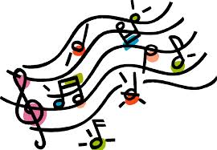
Week of October 22, 2018
Dates and Events
Goal(s) for the Week
- Students continue to develop their technique with scales, and they begin to apply that technique to music for our Winter Concert.
Fundamentals
- Tone
  - Breathing exercises
  - Steady sound
  - Balance concert F in sections, trios, etc.
  - Blend within sections; no heroes; sound like one
  - Balance across sections in the band
- Technique
  - All-region major scales: Bb, Eb, A, Db, G, C, F
    - Mini-scale and arpeggio in the same 7 keys
  - Rhythms: counting, playing, and sightreading
Music
- Fortitude by William Owens
  - Received in sectionals last week
  - March style, so steady rhythms and clear articulation
- Holiday Trio packets
  - Receiving in sectionals
  - Each section plays a different holiday song
  - For our Holiday Tour on December 14th

